Gyroscopic Roller Alignment Tool

Design Document

**DEC13-05**

Ted Beem

Ellen Laird

Aaron Peterson

Table of Contents

Executive Summary 2

Code Design 2

Circuit Design 2

User Interface Design 2

Physical Design 3

Definitions 3

PROPOSED SOLUTION 4

Goals 4

Deliverable Product 5

SYSTEM DESIGN 6

Requirements 6

Functional Decomposition 6

System Analysis 7

[1] System Input 8

[2] Gyroscopes 8

[3] Microcontroller 8

[4] System Displays 8

[5] USER 9

[6] Button Inputs 9

[7] Battery Pack 9

Materials/Components Used 9

Physical Specifications 10

Block Diagrams 11

DETAILED DESCTIPTION 12

I/O Specification 12

Interface Specification 12

Hardware Specification 13

Microcontroller 13

Gyroscope 14

LCD Screen 15

Software Specification 16

Simulations/Modeling 16

Implementation Challenges 17

Testing Procedures 17

PROJECT TEAM INFOMATION 18

Appendix 19

## Executive Summary

This document is composed of formal descriptions of the many steps involved in the design, development and implementation of the Gyroscopic Roller Alignment Tool. This tool will be used in order to more accurately calibrate the relative orientation of the various components of roller-based assembly machinery, thereby preventing compounded error in the machinery’s alignment and allowing for more precise production. The three major elements which work together to form this system are the Code Design, the PCB Design, and the User Interface Design.

## Code Design

As the alignment tool is designed for use as an independent embedded system with a supplementary computer-based client program, the on-board program for this project must be self-sufficient with defined variables for output to the client program. As this system is being designed from the circuit level, the overall process must handle data collection and internal processes in a very precise and regular manner.

## Circuit Design

The hardware of this tool will consist of three gyroscopes connected to a microcontroller. Each gyroscope will be placed at a different position in the tool in order to provide better detection of variations in position. The output of each scope will input to the microcontroller which will determine misalignment based on a previously stored value for pitch and yaw. These readings will be displayed on an LCD directly on the tool and sent through USB to a computer user interface. All components will be supplied with power via a battery directly on the tool. There will be a power switch which allows current to flow to the components. There will be two buttons next to the screen to be programmed for a ‘capture’ function and ‘zero’ function. The necessary components will be added to the circuit to drop input voltage to needed levels. The PCB will be designed using MultiSim and a gerber file will be generated to allow for manufacture of a two layer PCB.

## Graphical User Interface Design

The User Interface is used as a way for the user to receive and store all information for a current system of rollers, so that the user can access all information collected by the tool over a recent period. The user interface system uses this information to provide graphs of the rollers’ pitch and yaw offsets, compared to the master roller, and updates the graphs in real time.

This interface is used from a laptop or desktop computer with Java installed based on a laptop or desktop computer running a Windows environment and will communicate with the tool via a USB connection.

## Physical Design

The physical part of the tool is 12 inches long and 4 inches wide. It is in the shape of a chevron, an upside-down V, and has cut out little legs on the end to balance on rollers with large diameters. These legs help the user see that the tool is parallel to the roller, if it is not then the tool will wobble. For smaller roller diameters the roller fits into the V shape of the tool. The final tool is made out of aluminum and the tool is strapped on to the roller using two slip-resistant polyurethane-coated polyester straps that are feed through the four webbing mounting plates. The tool was designed in AutoCAD and was manufactured in house by PowerFilm Inc.

## Definitions

Master Roller – The roller that the alignment tool is calibrated to.

Zero – Set the gyroscope reference position to the current orientation.

Roll – Rotation of a system about the X axis

Pitch – Rotation of a system about the Y axis

Yaw – Rotation of a system about the Z axis

GUI – Graphical User Interface

# PROPOSED SOLUTION

The tool is designed with respect to a single use case, specifically being used by our client company (PowerFilm, Inc.) to align their roller-based machinery. During operation, the user will place the tool on a master roller and zero the tool to that alignment. The tool will then be subsequently moved to each additional roller in the machine and will display by what amount the orientation of the gyroscopes has changed due to the alignment differences between the master roller and the current roller.

It will display a live feed of this difference on an LCD screen as well as being able to connect to a computer through USB. Physical buttons are placed on the tool body so that key functions can be used independently of the tool’s connection to a GUI.

# Goals

In order to accomplish the completion of the alignment tool, the team has constructed the design of the system and its associated software in a succession necessary for further development. This will be done through a succession of stages as follows:

Stage 1: Finalize hardware and tool body designs  
 a. Obtain circuit components and define interfaces  
 b. Determine component connections and design layout   
Stage 2: Develop initial tool functionality  
 a. Implement connection from hardware to software  
 b. Create a basic computer interface to display output   
Stage 3: Interpret readings from environment  
 a. Implement capture of gyroscope information  
 b. Display live, processed measurements with calculations to LCD  
 c. Implement input/output to and from user interface  
Stage 4: Enable further tool features  
 a. Create graphic system for displaying read values  
 b. Manage internal memory usage   
Stage 5: Refine tool  
 a. Design and execute testing methods for software and real-world implementation  
 b. Design interface to better suit user needs

For the purposes of this project, each member of the three-person team is focusing on one of the major components discussed in the executive summary.

## Deliverable Product

The final product is an alignment tool specifically designed for use with machine rollers, based on a battery-powered microcontroller. The device will perform all measurements with the guidance of multiple on-board gyroscopes which will be calibrated to a single roller for comparison. The alignment tool will be able to output its reading to a client program on a separate computer system via a USB connection, which will in turn be able to capture the device output and graph this saved information.

# SYSTEM DESIGN

## Requirements

As specified in the project plan, the device fits within certain size constraints (twelve inches long, four inches tall and four inches wide) in order to most effectively fit within its operating environment. The device will must attach itself to each roller in a secure and stable position so that the tool can be said to be reliably aligned with the roller’s axis of rotation, which is accomplished through the use of a triangular base and multiple straps to fit various sizes of rollers.

The system detects its current orientation through the use of three gyroscopes in conjunction with a central microcontroller. All circuit components are mounted on a flat surface and protected by an outer shell, with these components connected to the client computer through a physical USB interface to provide more reliable communication. This system costs significantly less than the suggested $500 to construct and is not reliant upon a line of sight with the nearest roller to operate effectively. The system will be accurate within 0.8 degrees over a distance of 30ft. and provides reliable calculations regardless of its position on the roller’s surface.

## Functional Decomposition

The system collects a stream of real-time information about its current orientation and compares this information to a single saved measurement used as a point of reference. The microcontroller gathers and processes this data four output an LCD screen as well as receiving feedback from user input so that the tool may operate independently of its companion GUI. The client program handles the recording of multiple captured measurements and uses these to form a graph in real time consisting of a visual representation of each individual roller’s offset relative to the master roller.

## System Analysis

# 

Microcontroller

Gyroscope #1

Gyroscope #3

Gyroscope #2

Computer (User Interface)

LCD Screen

System Input (External Disturbance)

USER

Battery

[1]

[2]

[3]

[4]

[5]

[6]

[7]

Power

Zero

Save

[Button Inputs]

Figure 1: System Design

[1] System Input The tool is first placed on a master roller with the axis of the tool aligned with the axis of the roller. The user will press the ‘Zero’ button and the tool will take its current position and refer to that measurement as the ‘zero’ position.

Once this has been done the tool is moved to subsequent rollers. The difference in orientation between rollers will be the external disturbance for the system input.

[2] Gyroscopes There are three gyroscopes in the system. Their function is to take measurements of external disturbance, created by the tool being moved from one roller to the next, and send these readings on to the microcontroller.

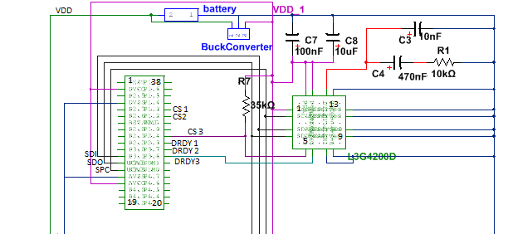

Shown above is the schematic of a single gyroscope depicting its connections to the microcontroller. The connections for all the gyroscopes are identical except pins 5 and 6. The dark blue lines to the right signify the ground line with pins 8-13 being specified to ground in the datasheet. The red line is connected to the phase locked loop, also specified in the datasheet. The pink line designates a power line of 3.3V which is generated from the 9V battery through the buck converter seen at the top of the schematic. C7 and C8 are also specified in the datasheet. R7 is a pull-up resistor which serves to insure pin 5 on the gyroscope is always high unless specified low. Pins 2-5 on each gyroscope are used for SPI communication with the microcontroller.

[3] Microcontroller The microcontroller is the heart of the system. It takes readings from the gyroscopes, the button inputs, and the computer. It calculates an average value for the pitch and yaw readings from each gyroscope so that instead of having six different readings the user receives two.

From the gyroscopes it takes the values they measure and display how far from the last zeroed position the tool is currently.

The microcontroller receives input from the button inputs, ‘Zero’ and ‘Save’. When the ‘Zero’ button is pressed the microcontroller stores the current readings from the gyroscopes as the default position and will take all future readings as relative to that position until the ‘Zero’ button is pressed again.

If the ‘Save’ button is pressed the microcontroller will store the current gyroscope readings as a vector. It will NOT use these values as a default position. The purpose of the ‘Save’ button is to store a current value, move to the next roller, store another value (etc…) and then plug into the computer and access the saved vectors. This allows the user to take measurements with the tool and generate a table of data if needed.

The microcontroller controls an LCD screen on which it will display current values for disturbance in pitch and yaw.

The microcontroller communicates with the computer through a USB interface. Through this interface it receives ‘Zero’ and ‘Save’ commands to perform exactly as described above. When the microcontroller is connected to the computer the user will be given an option to access saved vectors in the microcontroller memory.

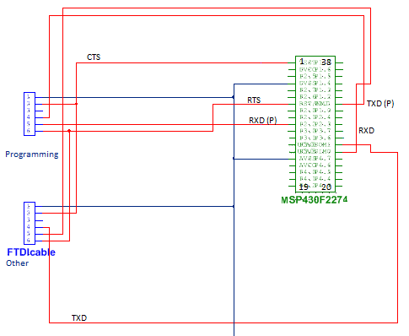

In the previous image is shown the schematic for the computer connections for the tool. There are two connections, one specifically for programming the microcontroller and the other for communicating information and commands with the computer. Programming of the microcontroller is done through TI’s MSP430G2 Launchpad which requires a slightly different connection than typical UART. The other connection is established using a cable built by the company FTDI which is specifically designed to translate from UART to a USB port on a computer.

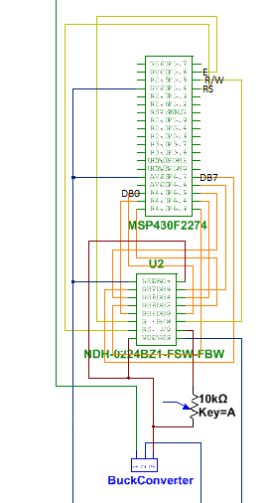[4] System Displays The LCD and computer are two different methods of displaying the readings from the gyroscopes. On the LCD the microcontroller displays the calculated averages of the readings it receives from all three gyroscopes. There are two buttons and a switch available next to the LCD that allow the user to give the tool basic commands.

The computer has a user interface that allows the user to access the on-chip memory of the microcontroller and thus view saved vectors of previous readings. The interface also allows the user to send the same commands that can be sent via the buttons by the LCD.

The image to the right is the schematic of the LCD connections to the microcontroller. Red lines signify a 5V power line supplied through another buck converter which converts 9V to 5V. Yellow lines are the communication lines through which the microcontroller can specify what type of commands it is sending and what the LCD needs to do. There are eight orange lines specifying the port of the LCD, this is where the actual characters transferred between the microcontroller and LCD.

[5] USER The USER is the person using the tool and sending commands via the buttons or computer. They also access data stored in the on-chip memory of the microcontroller through the user interface on the computer.

[6] Button Inputs The main purpose of the two buttons and switch being directly on the tool is so the tool can be used independently of the computer. The user need not have the computer connected to the tool in order to send commands and save data. This will be useful if the tool is aligning a roller that has no nearby surfaces on which to set a laptop.

On a similar note, the computer interface will be useful when the tool has to align a roller that is in an enclosed space and the LCD will not be readily visible.

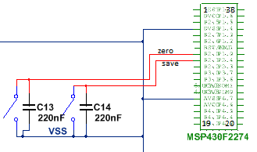

In this schematic the buttons are represented by switches with debouncing capacitors in parallel to provide a more reliable reading of the button. The last input, the power switch, is inserted near the battery connection and will control the availability of the 9V to the rest of the circuit.

[7] Battery Pack The tool has an onboard battery pack which supplies power to the microcontroller, gyroscopes and LCD. When the ‘Power’ switch is turned ON the battery will begin supplying power to the components on the tool and will continue to do so until the ‘Power’ switch is changed to OFF.

It has been determined that a 9V battery will be used to provide power to all componenents on the board.

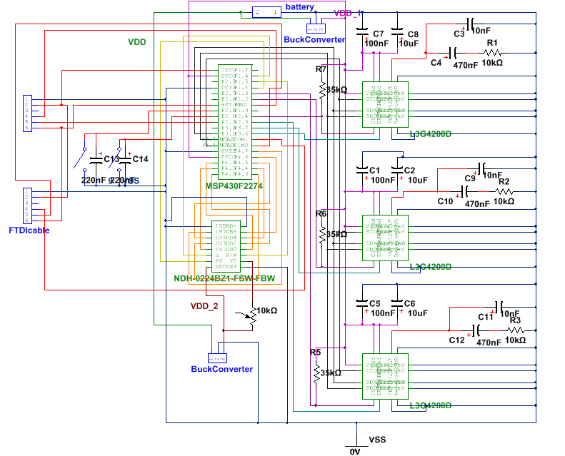

Above is a screen shot of the entire schematic for the hardware design. All three gyroscopes can be seen along the right side of the image, each has a phase locked loop and pull-up resistor. At the top is the battery connection and the 3.3V buck converter. To the left are the representations of the computer connections and just to the right are the ‘Zero’ and ‘Save’ buttons. Directly below the microcontroller is the LCD and below the LCD is the 5V buck converter.

This schematic was built using Multisim 12.0 and then transferred to Ultiboard 12.0 to generate a PCB design, which can be seen on the next page.

# 

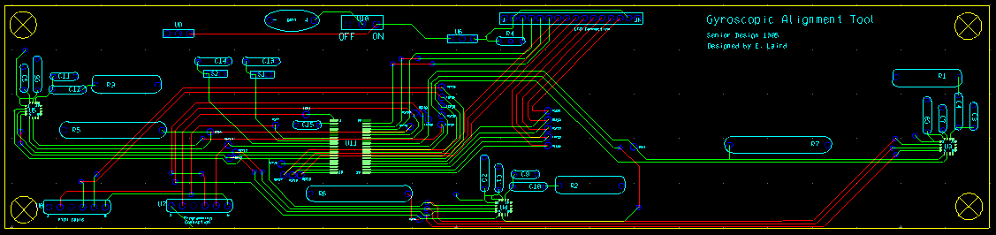PCB layout of the final schematic design. The board is nine inches long and two inches high with a gyroscope on each end and another in the middle. There are six layers to the PCB: copper top, copper bottom, solder mask top, solder mask bottom, silk screen top, and silk screen bottom.

## File:MSP430 ValueLine LP.jpgProgramming Connection

When designing the tool we encountered the problem of how to program the microcontroller. As it turns out TI has made a tool designed to interface between a computer and any of their MSP430 micorocontrollers. The MSP430G2 Launchpad just requires a six pin connection to the MSP430F2274 to allow programming via the on board BSL. We have implemented this solution and as can be seen on the next page the board itself cost less than ten dollars.

Below is a table showing the connection specific to this microcontroller recommended by TI for using BSL to program.

|  |  |
| --- | --- |
| Launchpad | Destination Pin on MSP430 |
| J6.1 (VCC) | (VCC) |
| J6.3 (GND) | (GND) |
| J2.14 (P1.6) | Pin 32 (P1.1, BSL Transmit) |
| J2.15 (P1.7) | Pin 10 (P2.2, BSL Receive) |
| J1.6 (P1.4) | Pin 7 (RST) |
| J1.7 (P1.5) | Pin 1 (TEST) |

# Materials/Components Used

Figure 2: Materials/Components

# Physical Specifications

The tool is in the shape of a chevron. It is 12 inches long and 4 inches wide. The final tool will be made out of aluminum. Our demo tool is just made out of foam. The chevron is ¾ inches thick and the PCB rests on top of one side while the LCD screen and battery holder rests on the other. The PCB, LCD, and battery holder are attached to the tool with screws and the tool has four mounting plates attached to the ends of the tool. To attach the tool to the roller two slip-resistant polyurethane-coated polyester straps are used. The straps feed through the hole in the mounting plates and have a buckle at one end so they can be tightened.

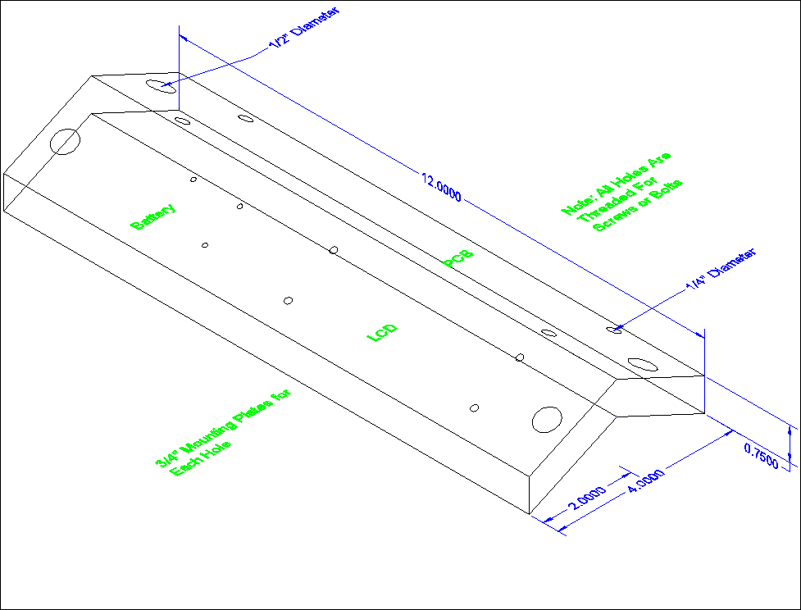

# Block Diagrams

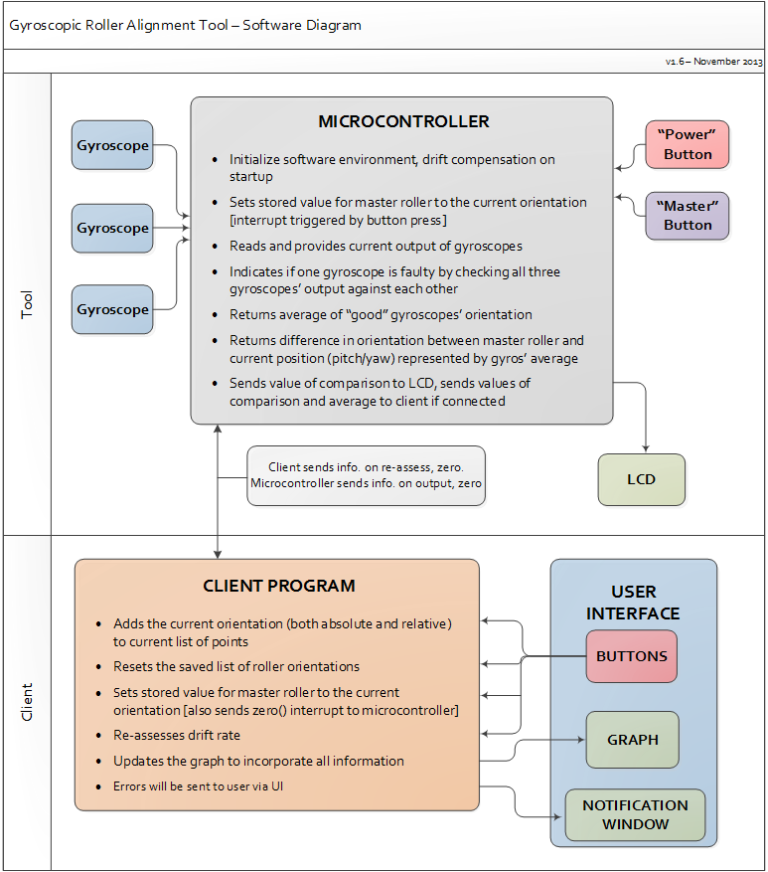

**Software Module Interaction**

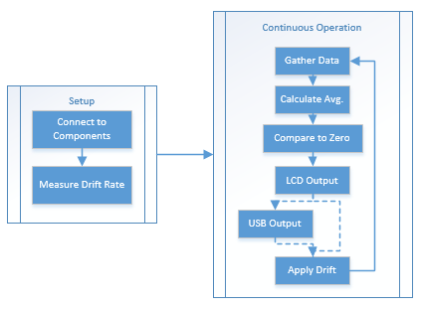

**Embedded Software Operation Cycle**

# DETAILED DESCTIPTION

## I/O Specification

This system will utilize SPI standards in order to facilitate inter-device communication in a C programming environment.

Hardware Interface Task List

* Uses an LCD screen to display the offset in pitch and yaw in positive or negative degrees.
* Includes a switch to power the tool on or off.
* Includes a button to zero the alignment tool to the roller.
* Includes a button to store the pitch and yaw offset values in memory.

## Interface Specification

GUI Task List

* Displays the difference between in pitch and yaw in the master roller and current roller, in terms of positive or negative degrees.
* Includes buttons to zero the alignment tool, record the current alignment offsets, and reset the stored offset values.
* Ability to display notification and error messages.
* Graphs of the difference in pitch and yaw between different rollers.
* Updates in real time.

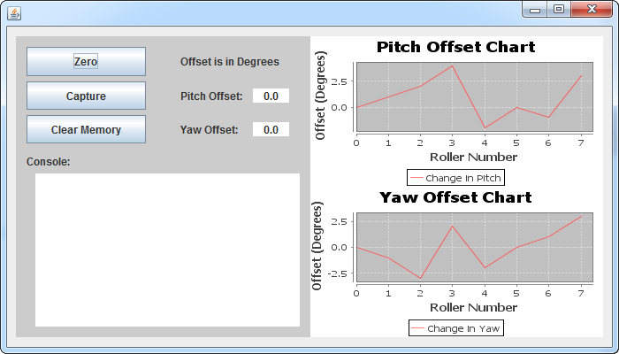

# Hardware Specification

## Microcontroller

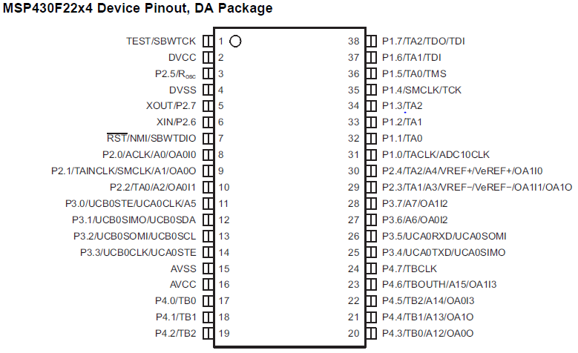

Pin 2 (DVcc): Digital supply voltage, positive terminal

Pin 4 (DVss): Digital supply voltage, negative terminal

Pin 11 (USCI_B0) Slave transmit enable

Pin 12 (USCI_B0) SPI Mode: Slave in/master out

Pin 13 (USCI_B0) SPI Mode: Slave out/master in

Pin 14 (USCI_B0) Clock input/output

Pin 25 (USCI_A0) UART Mode: transmit data output

Pin 26 (USCI_A0) UART Mode: receive data input

Pins 17-24 (Port 4) General-purpose digital I/O

## Gyroscope

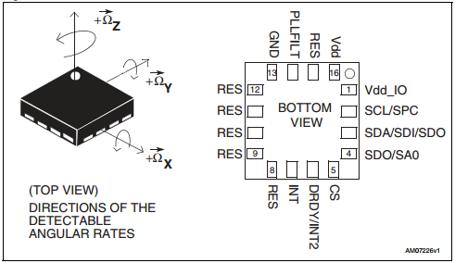

Figure 4: Gyroscope Pinout

Pinout of L3G4200D (courtesy of download.siliconexpert.com/pdfs/2011/1/10/2/27/32/108/st_/manual/17116.pdf)

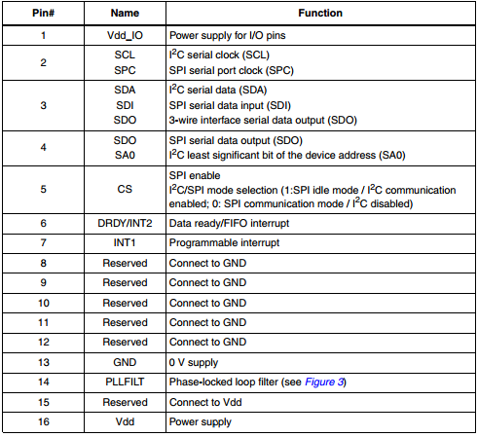

## LCD Screen

Figure 5: LCD diagram and pinout

Courtesy of http://www.newhavendisplay.com/nhd0224bz1fswfbw-p-389.html

# Software Specification

The user of the tool is able to receive information in two ways. The primary and most detailed method is via a graphical computer-based client program. This program displays the gyroscopes’ output in real-time and can capture and graph the current output in order to compare the position of multiple rollers within a single machine. The other method is through a simple 16-digit LCD which only outputs the device’s current reading of pitch and yaw. This allows for portable use without dependency on the client program.

# Simulations/Modeling

Embedded System Model: Current simulations of Microprocessor behavior are being handled using the eZ430-RF2500 Wireless Development Tool by TI through version 5 of their own Code Composer Studio IDE.

Computer Connection Model: Here we will have a model showing how the device connects to the computer software.

GUI Model: Here we will have a model showing how the GUI connects to the computer software.

# Implementation Challenges

Various components of this project, such as the PCB and the implementation of a GUI, utilized interfaces and systems with which the team had not previously worked with, creating a learning curve we had overcome before any implantation could take place. In addition, the software required a familiarity with classical physics and advanced mathematics in addition to electrical and computer engineering in order correctly handle the processing of all information received from the gyroscopes. Finally, the components used in this project are highly compact and required a very delicate position during the construction phase of the project.

# Testing Procedures

Physical test rollers were set up using PBC pipes which and were at a known displacement from each other. The misalignment between ‘rollers’ in this system is known we can determine when the tool is working correctly. After functionality was proven for known distances we moved on to random amounts of displacement.

We set up some automated tests for the embedded software and the computer interface. For the computer interface we also several test users help find bugs and determine if the interface had good usability.

# PROJECT TEAM INFOMATION

Project Team Information

**Faculty Advisor**

Degang Chen

Department of Electrical and Computer Engineering

[djchen@iastate.edu](mailto:djchen@iastate.edu)

**Team Members**

Ted Beem

Webmaster, User Interface Design

Computer Engineering

[tedbeem@iastate.edu](mailto:tedbeem@iastate.edu)

Ellen Laird

Communications Officer, Hardware Design

Electrical Engineering

[ellen.laird279@gmail.com](mailto:ellen.laird279@gmail.com)

Aaron Peterson

Team Leader, Embedded System Design

Computer Engineering

[apeter0807@gmail.com](mailto:apeter0807@gmail.com)

# Appendix

**Operations Manual**

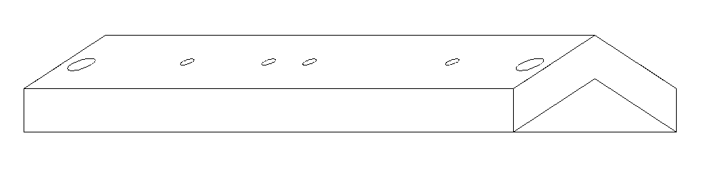

**Instructions:**

1. Place the tool on a flat, stable surface.
2. Press and hold the “POWER” button on the tool face for two seconds.
3. Wait for at least ten seconds, or until the LCD begins to display a numerical output.
4. (Optional) Plug the tool’s USB cable into the USB port of a computer with the tool’s software interface installed.
5. (Optional) Open the tool software on your computer and follow any on-screen instructions.
6. Place the tool securely on top of the first roller of your machine.
7. Use the tool’s straps to securely attach the tool body to the roller.
8. Press and hold the “ZERO” button on the tool face for two seconds or press the Zero button on the tool software, then wait until the LCD displays a value of approximately zero.
9. Place the tool on the next roller in the machine and attach securely as before.
10. Adjust the roller accordingly until the LCD displays a value of approximately zero.
11. (Optional) If connected to via USB, you may press the “SAVE” button on the tool or the tool software to save the currently-measured value to the graph displayed in the tool software.
12. (Optional) You may set the current measurement as the tool’s point of reference at any time by repeating Step 8.
13. Repeat Steps 9-12 for each subsequent roller in the machine.

**Troubleshooting:**

If the readings gathered by the tool appear to become gradually less accurate with respect to the tool’s point of reference, you can reset the tool’s measurement gathering by turning the tool off or using the “reset drift correction” option in the tool software.

If the LCD display is dim or the tool is unresponsive, you may need to replace the tool’s batteries by unscrewing the battery compartment lid from the tool body to access the battery compartment.